

**COMSATS University Islamabad (CUI)**

Project Proposal   
(SCOPE DOCUMENT)

For

**E-Voting Management System**

**BCS-4-A**

***Submitted By***

**Hunia Nadeem CUI/FA20-BCS-024/ISB**

**Minahil Fatima CUI/FA20-BCS-037/ISB**

***Submitted To*  
Mr. Qasim Malik**

***(Date of Submission: 7th July 2022)***

*Bachelor of Science in Computer Science (2020-2024)*

**Table of Contents**

Abstract 1

1. Introduction 2

2. Proposed System 2

3. Advantages/Benefits of Proposed System 2

4. Scope 3

5. Modules 3

5.1 Module 1: Profile Management 3

5.1.1 Sign up 3

5.1.2 Log in 3

5.1.3 Forget Password 4

5.1.4 View Profile 4

5.1.5 Edit Profile 4

5.1.6 CNIC Authentication 4

5.1.7 Generate User ID 4

5.2 Module 2: Election Management 4

5.2.1 Create election 4

5.2.2 Moderate elections 4

5.2.3 Add candidates 4

5.2.4 Add parties 4

5.2.5 Add voters list 4

5.2.6 Register voters 4

5.2.7 Generate voter ID 4

5.2.8 Cast vote 4

5.2.9 Appoint Party Admin 4

5.2.10 View Candidate details 4

5.2.11 View group details 4

5.3 Module 3: Election Category Definition 5

5.3.1 Organization 5

5.3.2 Government 5

5.3.3 Referendum 5

5.3.4 Custom 5

5.4 Module 4: Result Management 5

5.4.1 Count Votes 5

5.4.2 Generate Report 5

5.4.3 View Results 5

5.5 Module 5: Feedback and Support 5

5.5.1 Send Feedback 5

5.5.2 Give Rating 5

5.5.3 View ‘About Us’ Details 5

6. System Limitations/Constraints 6

7. Entity Relationship diagram 7

8. Graphical User Interface (GUI) 9

9. Tools and Technologies 12

10. Work Division 12

11. Conclusion 12

12. References 13

# 

**Project Category:**

**A-**Desktop Application/Information

# Abstract

Casting votes in a democratic structure strengthens the integrity of the people. So, to ease the entire process of casting votes, the **Online Voting Management System** is a **desktop application** that makes the users a click away from starting their elections to securely casting votes to reviewing the results of elections. By **automating** the voting process, problems like **rigged elections**, **errors in voters’ lists**, **errors in the counting process**, and **transport of voters** to the voting stations can be avoided on a large scale.

This system provides a plethora of **election and voting management options**. The moderators can create elections for any small to large-scale event and manage the results. In contrast, the voters can cast votes by registering themselves for it. The app is feasible for all due to the internet availability. It will play a significant role in **easing the voting process** by saving time, travel costs, and energy.   

# Introduction

Elections play a vital role in the democratic structure of organizations. It gives people the power to elect the rightful people. Previously, the entire voting process was handled manually. From setting up voting stations to registering voters to conducting on-site voting with utmost security and responsibility. Despite all the care, there were always some grey areas left unchecked that paved the way for uncertain, unfair and rigged elections. Furthermore, the hassle and fatigue that manual voting brings are unprecedented. The arrangement of secure voting stations and sufficient ballots, the requirement of ample people for the procession of the voting process and counting of votes, and effective administrative management are some of the many setbacks people faced during the manual voting process.

Fortunately, this issue can easily be resolved by automating the entire voting process. Not only is it smart, but it is also highly effective in resolving avoidable issues, like lack of workers, insufficient ballots, transport, security, and unregulated voters – enabling the smooth and stress-free organization of elections. The Online Voting Management System provides a platform where people can easily and securely arrange online elections, manage the candidates and voters’ list, and review the results. The election can be conducted for any small to large-scale event. With a user-friendly interface, the users will have access to a hassle-free voting system that they can operate from anywhere.

The project will focus on providing a user-friendly interface and maintaining a secure database for data related to the elections. Hence, the project will give us the ground for practicing team work and understanding the project domain, along with data entry, data management, and enhancement of user-friendliness of interfaces.

# Proposed System

The Online Voting Management System will provide one platform for accessing and managing the entire voting process. By fully automating the process, the user will only need access to a stable internet connection for playing their democratic role. There will be no need for ballots, voting stations, copies of registration forms, and ample people for conducting the voting process. The user will be able to organize any category of election ranging from small-scale custom voting to large-scale political elections or referendums. They can even limit the number of voters and review auto-generated results without any possible human error. The voters can view details of the standing parties and candidates and maintain the history of their votes.

# Advantages/Benefits of Proposed System

Following are the advantages of “Online Voting Management System”:

* It is **accessible & easy to use** due to its accessibility across a variety of devices - such as smartphones, tablets, and computers -making the entire voting process as simple as a click of a button or a tap on a screen.
* It provides **security** which includes single-vote verification, a secure network to protect the entire process from nominations to tabulations, and also making sure that the members that are accredited are allowed to participate in the election.
* Online voting **reduces elections cost** significantly. It saves the price of printing and mailing thousands of ballots, and eliminates the cost of renting a polling location.
* Election **results** can be reported and **published faster.**
* **Accuracy** is the most significant advantage of online voting. It boasts security systems that ensure every vote is being counted in real-time.
* The online voting system **eases the tedious voting**process and gives an inviting experience to both voters and moderators.

# Scope

The “**Online Voting Management System**” is a web-based voting system that will help users manage their elections easily and securely. The voters do not have to go to the polling booth to cast vote through this system. Instead, they can use their computers to cast their votes.

The user has to create an account on the system. The user login to the system using email address and password. The System Moderator adds candidates, parties, and a list of voters to the system or registers the voters through a registration form using CNIC authentication. After registration, the voter is assigned a unique voter ID which they can use to cast vote. If invalid credentials are submitted, the person will not be registered to vote. There will be a database maintained for storing the detail of voters. The user can also view or edit their profile.

This system can organize any category of election ranging from small-scale custom voting to large-scale political elections or referendums. The election's privacy can be set to public or private according to the scope of the election. The voting will be activated only at the scheduled time of the elections. Users can view the results of the respective elections. The users can view details of the standing parties and candidates, and maintain the history of their votes. They can also give feedback on their experience with the application.

# Modules

The major modules for “Online Voting Management System” are listed below:

## Module 1: Profile Management

This module manages the creation of user account and its profile management related tasks.

### Sign up

This enables the user to create an account on the system by entering required valid credentials.

### Log in

This enables user to login the system by entering the username and password created in sign up.

### Forget Password

This enables user to recover or reset password if they forget the current password.

### View Profile

This enables user to view his profile.

### Edit Profile

This enables user to edit his profile details.

### CNIC Authentication

This function ensure that the CNIC entered by the user is a valid CNIC or not by matching it with the CNIC present in the citizen database.

### Generate User ID

This function generates a unique ID for each user registered in the system for login purpose.

## Module 2: Election Management

### Create election

This enables the user or moderator to create elections by entering election details like date, start and end time, election category, candidate details etc.

### Moderate elections

This functionality enables the user to create public or private elections as per their requirements.

### Add candidates

This enables the moderator to add candidate in the respective election by entering candidate details and few credentials.

### Add parties

This enables the moderator to add parties and their candidate’s details while creating an election.

### Add voters list

This enables moderator to add the specific voters in the voters list of a particular election.

### Register voters

This enables the registration of voter so that they can cast vote in the respective election through a registration form.

### Generate voter ID

This function generates a unique Voter ID for the registered voter so that they can cast vote in the particular election by entering their unique voter ID for authentication.

### Cast vote

This will enable the registered voters to cast vote using their unique Voter ID.

### Appoint Party Admin

This will enable the moderator to add the admin of a particular party who will coordinate and manage all the election related activities.

### View Candidate details

This will enable the user to view the details of the candidates taking part in the election.

### View group details

This will enable the user to view a group or party details, their history and experience etc.

## Module 3: Election Category Definition

This module defines different election categories through which user can organize elections as per their requirements.

### Organization

This category involves the conduction of elections within the organization or institutes.

### Government

This category involves the conduction of elections of political parties at national or local level.

### Referendum

This category involves the conduction of referendum for acceptance or rejection of a proposal, law, or political matter.

### Custom

This category involves the conduction of custom elections as per the user needs and requirements. These types of elections have limited number of candidates and voters. For example, elections held in different sports and educational institutions.

## Module 4: Result Management

This module manages the result of the elections including counting votes and generating election result reports.

### Count Votes

This function counts the vote of the particular election.

### Generate Report

This function generates the particular election result report according to the counting of votes.

### View Results

This enables the user to view the election results in which they have casted vote.

## Module 5: Feedback and Support

### Send Feedback

A user can send feedback to the system about their experience with the application.

### Give Rating

The user can rate the application by giving stars out of 5.

### View ‘About Us’ Details

This enables user to view the brief application details.

# System Limitations/Constraints

Following are the limitations of our proposed system:

* The user must have an account in the system in order to use the system.
* A non-registered voter cannot caste vote.
* CNIC verification is mandatory for the registration of a voter.
* The voting option will be activated only at the scheduled time of the elections.

# Diagram, schematic Description automatically generatedEntity Relationship diagram

Figure 1: Logical ERD for E Voting Management System

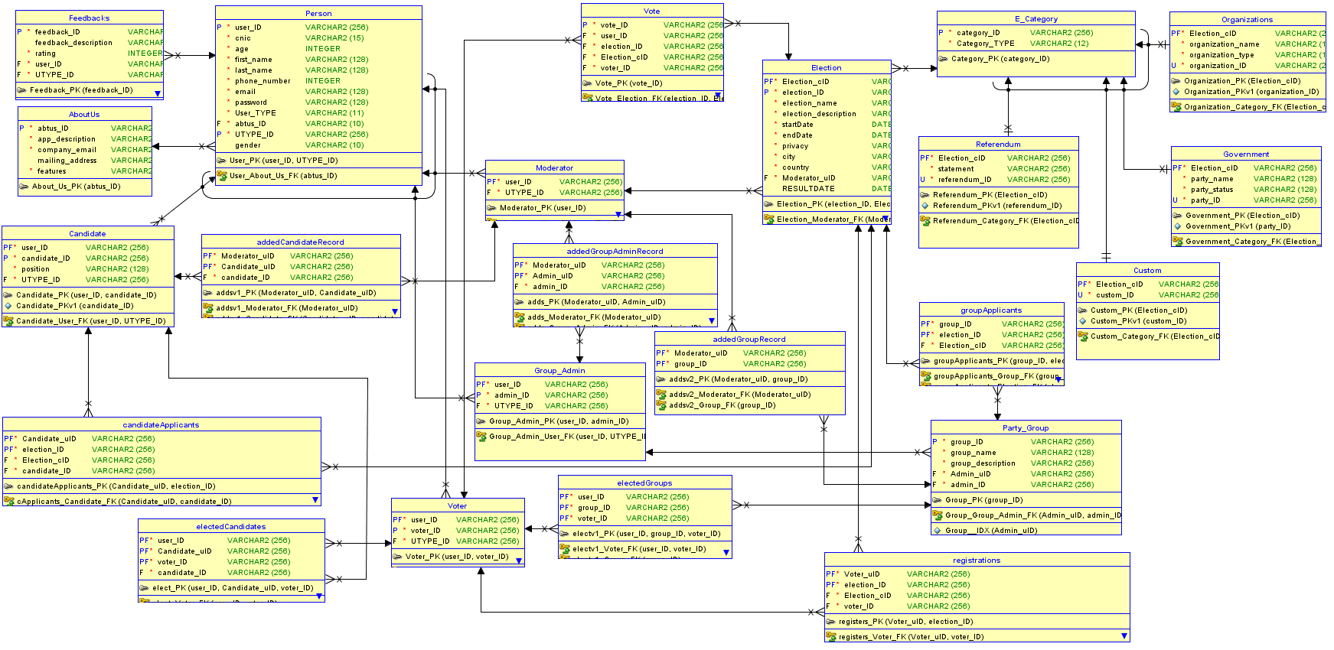**Figure 2: Relational ERD for E Voting Management System**

# Graphical User Interface (GUI)

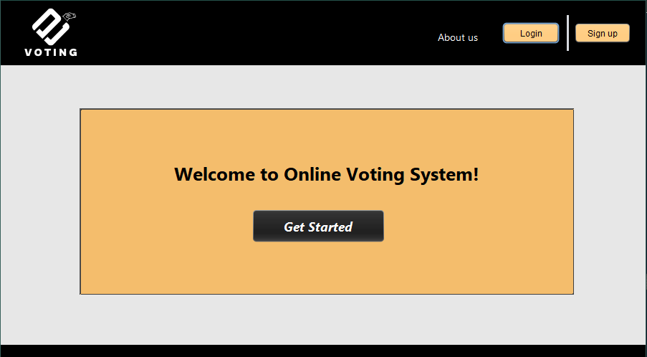

Figure 1: Home page

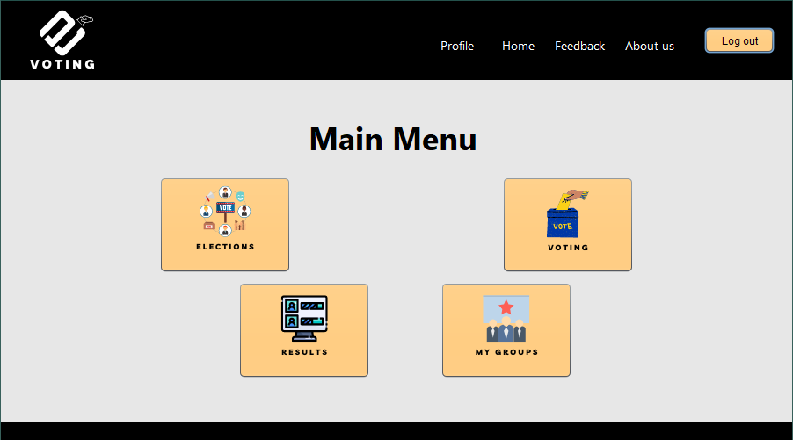

Figure 2: Main Menu

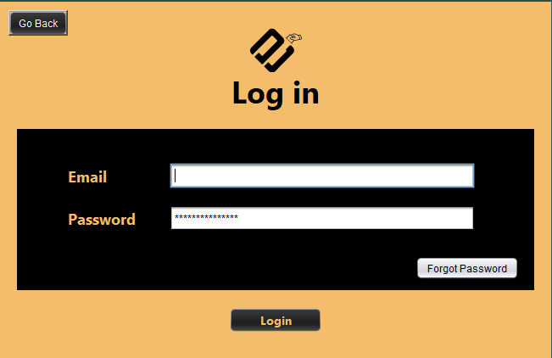

Figure 3: Login

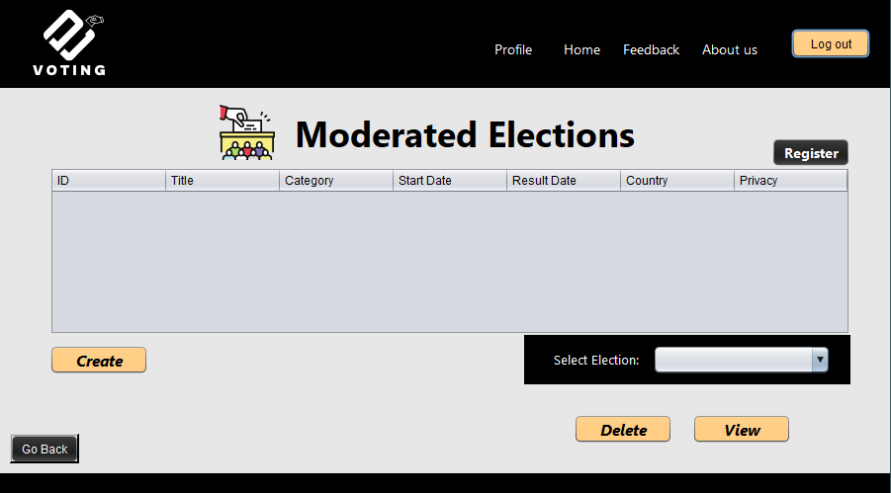

Figure 4: Election Main Screen

Figure 5: Voting Main Screen

Figure 6: Feedback

# Tools and Technologies

|  |  |  |  |
| --- | --- | --- | --- |
| Tools  And  Technologies | Tools | Version | Rationale |
| NetBeans | 2020.3.4 | IDE |
| Oracle Server | 19c | DBMS |
| Atlas Cloud Database | 5.0 | DBMS |
| Swing | Java Platform SE 7 | User Interface |
| MS Word | 2019 | Documentation |
| **Technology** | **Version** | **Rationale** |
| Java | 16.0.2 | Programming language |
| SQL | 2013 | R Query Language |
| MongoDB | 2019 | Non-R Query Language |
| JFrame | Java Platform SE 7 | Event handling |

# Work Division

|  |  |
| --- | --- |
| **Hunia Nadeem**  **(FA20-BCS-024)** | **Minahil Fatima**  **(FA20-BCS-037)** |
| 1. Modules (GUI + Implementation)    1. Login – Signup – Forgot Password    2. Profiling    3. Election Creation - View - Deletion 2. Database Implementation    1. SQL    2. Mongo 3. ERD    1. Discussion    2. Main implementation | 1. Modules (GUI + Implementation)    1. Voting – Registrations    2. About us – Feedback    3. View Election Results 2. Database Implementation    1. SQL 3. ERD    1. Discussion    2. Proofreading |

# Conclusion

The Online Voting Management System’s ultimate objective is to resolve the prime problems that surface during onsite elections. By automating the entire voting process, the issues revolving around the rigged election, the requirement of ample people, counting errors, insufficient ballots, and consumption of energy, cost, and time will be promptly handled. Digital voting and a user-friendly interface will provide a secure and smooth user experience. Nonetheless, a plethora of election and voting management will be a click away from a common man.

# References

(n.d.). Retrieved from https://www.yeselections.com/blog/what-are-the-leading-benefits-of-online-voting

(n.d.). Retrieved from https://www.verovoting.com.au/blog/benefits-of-online-voting/